Tavern on the Green Reopens, with Central Park as Its Centerpiece
April 24, 2014 10:39 AM

Following a brick-by-brick renovation, NYC restaurant Tavern on the Green is back, and its formerly over-the-top interiors have been transformed with a “robber-baron-meets-sheep-barn” aesthetic and the aspiration to be “food-centric.” We sent writer Nancy Lazarus to take a peek under the famous red canopy.

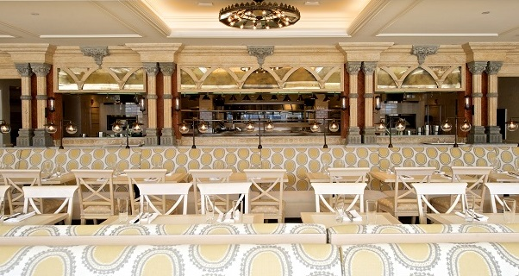
The sunny Central Park room at the new Tavern on the Green was formerly known as the Crystal Room. (All photos courtesy Robin Caiola)
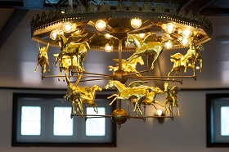“Now we can be part of the park,” said restaurateur Jim Caiola, referring to the recently reopened landmark, Tavern on the Green. He and partner David Salama of Emerald Green Group were awarded a 20-year lease to the legendary restaurant, long associated with Broadway show parties, special family occasions, and a role serving as movie backdrop.
“Only the name, the beams and the shell of the Victorian building remain from the old Tavern”, said spokesperson Steven Hall. “Everything else was handpicked by Jim and David.” The pair renovated the interior, while the property’s New York City landlord worked on the exterior. Others involved in the restoration were architect Richard Lewis, lighting designer Ken Billington, and landscape architect Robin Key. It’s been a major investment and long haul.
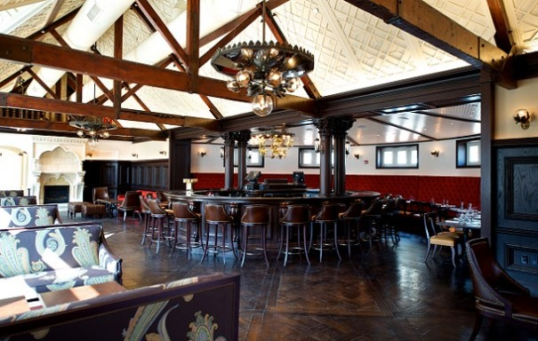
Little is left over now after the court-ordered auction of the ornate contents in early 2010. Under the ownership of Warner LeRoy, Tavern was one of the nation’s highest grossing restaurants, but by 2009 his family declared bankruptcy. New Year’s Eve marked the last supper and final event.
The new owners’ “TLC” approach was evident not only in their attention to design details, but also by broadening the appeal to a range of patrons: tourists and locals alike. During my recent preview tour, passers-by stopped in for a sneak peek. The inclusive M.O. is reflected in Tavern’s open decor, extensive menu, and reservations policy, which allows for walk-ins.
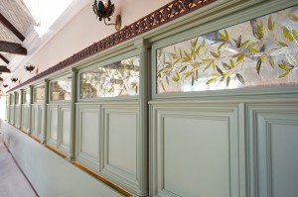While Tavern during LeRoy’s tenure was about over-the-top glitz, the new, more compact version is a throwback to more rustic décor, with elegant touches. The Tavern originally served as a shelter for sheep in Central Park’s Sheep Meadow before New York’s Parks Commissioner, Robert Moses, turned it into a restaurant in 1934. Now beamed ceilings are a focal point, starting with the bar room. Other highlights there are an oval mahogany bar, gold leaf flying horse mobile lighting fixture, a ventless fireplace and semi-circular red banquettes.
Tavern’s fortunes have paralleled not only those of the national economy, but also of New York City and Central Park. The most striking changes are the open kitchen and panoramic vista from the sunny Central Park room, formerly the Crystal Room, to the greenery and courtyard outside. LeRoy had built a wall of trees and shrubbery around the courtyard to shield patrons from the rundown, crime-ridden park of the 1970s.
The adjacent South Wing is slated for dining and events, and its moss green and earth tone color scheme feature upholstered walls, antique glass light fixtures, tan paisley upholstered chair seats, and hand-painted gold mirror panels with botanical motifs.
At the far end is the ‘Green To Go’ window, where park-goers can order food and beverages and relax on the South Terrace. Many new trees and shrubs are being planted, but the plan is for the building to be uplit, rather than lighting the trees as in the prior era.
The menu, by chef Katy Sparks, serves lunch, dinner, and weekend brunch, offering small and large plates and seasonal ingredients under the headings Hearth, Grill, and Plancha. There’s a range of cocktails, including one named after each of New York City’s five boroughs. The liquors carry historical references, such as Dorothy Parker gin and Bootlegger vodka, and guests can sip them alfresco on the Bar Terrace.
The first or last stop for most patrons will likely be the gift shop at the main entrance. Much like the nostalgic auction bidders seeking memorabilia four years ago, many will want a souvenir of their Tavern on the Green experience.
Writer Nancy Lazarus is a frequent contributor to UnBeige.

